EXPT NO:6 | OVER-PLOTTING REDUCTION TECHNIQUES
DATE: 09.02.2026

PRE-LAB QUESTIONS
- Why is over-plotting common in big data visualization?
Over-plotting is common in big data visualization because large datasets contain a huge number of data points that must be displayed within limited screen space. When many points share similar values, they overlap on the graph, making individual data points difficult or impossible to distinguish.

- How does data density affect perception?
Data density affects perception by creating visual crowding in dense regions of a plot. When too many points appear in the same area, patterns, trends, and outliers can become hidden, and viewers may incorrectly estimate the distribution or importance of certain values.

- What trade-offs exist between detail and clarity?
The main trade-off between detail and clarity is that showing every data point preserves accuracy but often results in cluttered and confusing visuals, while simplifying or aggregating data improves readability but may remove fine-grained details and subtle patterns.

- How do AI datasets increase visualization complexity?
AI datasets increase visualization complexity because they are typically very large, high-dimensional, and continuously growing. Representing multiple features and their relationships in a single visualization becomes challenging, especially when limited to two or three dimensions.

- Why is over-plotting a serious analytical risk?
Over-plotting is a serious analytical risk because it can obscure important insights such as trends, clusters, and anomalies. This visual distortion can lead analysts to misinterpret the data and draw incorrect conclusions, ultimately affecting decision-making.

OBJECTIVE : To apply techniques that reduce visual clutter in large-scale datasets.

SCENARIO A social media analytics company visualizes millions of user interactions to study engagement patterns.

IN-LAB TASKS (Using R Language) • Apply alpha blending • Implement jittering techniques • Use aggregation and binning

CODE:
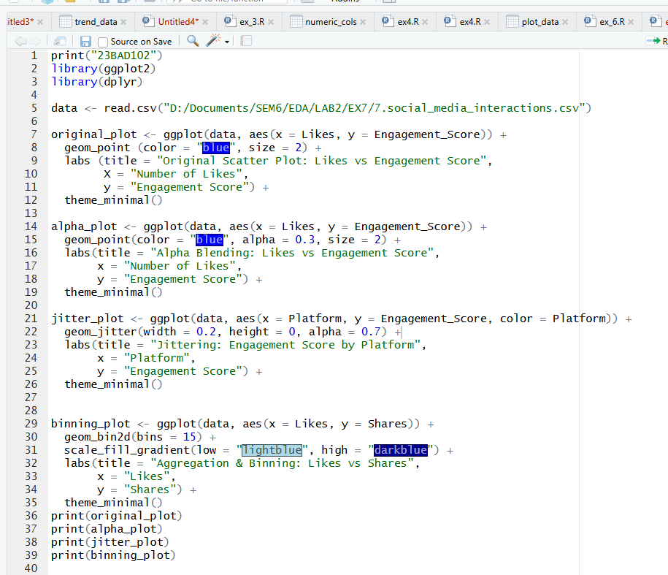

OUTPUT:

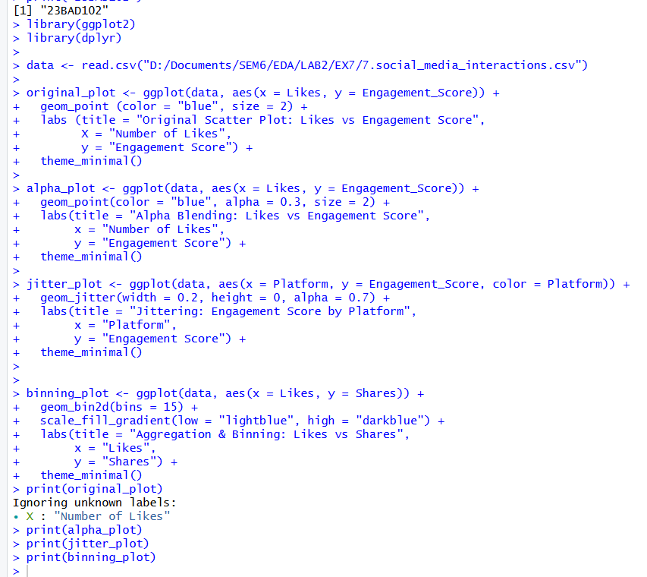
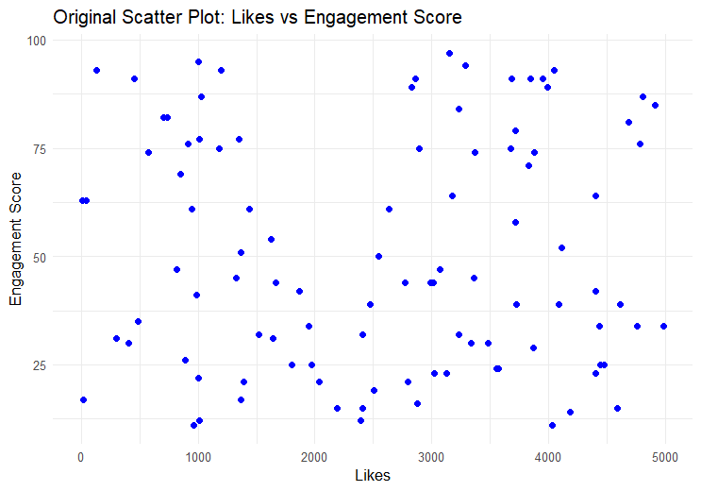
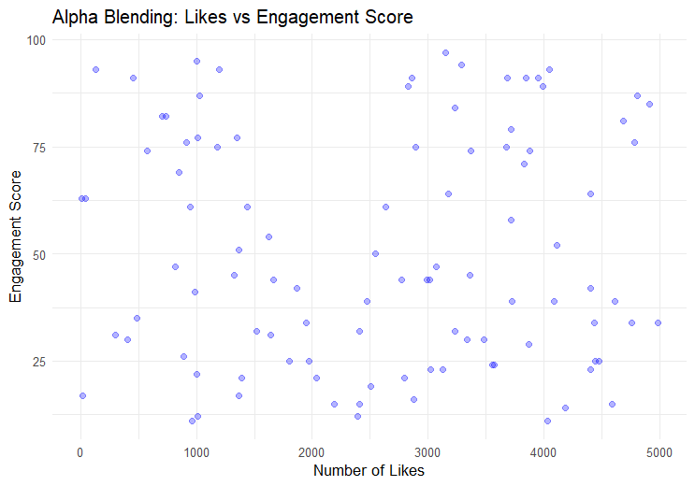

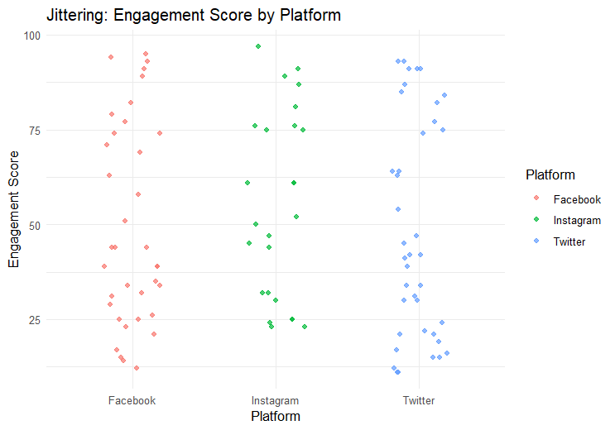

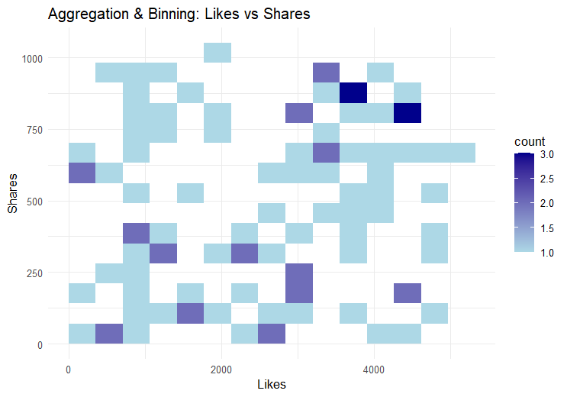
POST-LAB QUESTIONS
- Which technique provided the best clarity and why?
The technique that provided the best clarity is aggregation and binning because it reduces visual clutter by grouping data points into bins and showing their density. Instead of overlapping points, it highlights patterns and concentration areas clearly, making it easier to interpret relationships between likes and shares in large datasets.

- How does over-plotting distort analytical conclusions?
Over-plotting distorts analytical conclusions by hiding the true distribution of data. When many points overlap, dense regions may appear sparse and outliers may go unnoticed, which can lead to incorrect assumptions about trends, correlations, or variability in the data.

- When should aggregation be preferred over raw plotting?
Aggregation should be preferred over raw plotting when dealing with large datasets or high data density. In such cases, raw plots become cluttered and unreadable, whereas aggregation summarizes the data effectively and reveals overall patterns without overwhelming the viewer.

- How do these techniques support scalable AI analytics?
These techniques support scalable AI analytics by enabling efficient visualization of large and complex datasets. Methods like alpha blending, jittering, and binning allow analysts to understand model behavior, data distributions, and trends even when working with millions of data points typical in AI systems.

- Explain real-world consequences of ignoring over-plotting.
Ignoring over-plotting in real-world scenarios can lead to serious consequences such as faulty business decisions, incorrect model evaluations, and missed anomalies. For example, misleading visual insights can cause organizations to misjudge user engagement, predict trends inaccurately, or deploy poorly performing AI models.

LEARNING OUTCOME: Students master over-plotting reduction for big data visual analytics.
ASSESSMENT
Description | Max Marks | Marks Awarded
Pre Lab Exercise | 5
In Lab Exercise | 10
Post Lab Exercise | 5
Viva | 10
Total | 30
Faculty Signature

